|  |  |
| --- | --- |
| Logo_FPT_University_doc | **MINISTRY OF EDUCATION AND TRAINING** |

**FPT UNIVERSITY**

**CAPSTONE PROJECT DOCUMENT**

**BSMS**

**Report #6 – User's Manual Documents**

|  |  |
| --- | --- |
| **Bookstore Management System** | |
| Group Member | SE03975 - Olasehinde Ezekiel Olaoluwa |
| SE03444 - Kanda Joshua David |
| SE03520 - Shunom Peter Bala |
| Supervisor | Bui Đinh Chien |
| Ext. Supervisor |  |
| Project Code | BSMS |

Table of Contents

[1 INSTALLATION GUIDE 4](#_Toc490293161)

[1.1 Purposes 4](#_Toc490293162)

[1.2 Environments 4](#_Toc490293163)

[1.3 Application Installation 4](#_Toc490293164)

[1.3.1 .Net Framework 3.5 4](#_Toc490293165)

[1.3.2 Sql Server 2014 6](#_Toc490293166)

[1.3.3 Visual Studio 2015 13](#_Toc490293167)

[2 USER's GUIDE 22](#_Toc490293168)

[2.1 Purposes 22](#_Toc490293169)

[2.2 Functional Description 23](#_Toc490293170)

[2.3 Detailed Guidelines 23](#_Toc490293171)

[2.3.1 Login 23](#_Toc490293172)

[2.3.2 Register 23](#_Toc490293173)

[2.3.3 View Books 24](#_Toc490293174)

[2.3.4 Read Online 26](#_Toc490293175)

[2.3.5 Download Book 27](#_Toc490293176)

[2.3.6 Like Book 28](#_Toc490293177)

[2.3.7 Dislike Book 30](#_Toc490293178)

[2.3.8 Rate Book 30](#_Toc490293179)

[2.3.9 Like Book 30](#_Toc490293180)

[2.3.10 Add Book To Wish list 30](#_Toc490293181)

[2.3.11 View Wish list 32](#_Toc490293182)

[2.3.12 Remove from Wishlist 33](#_Toc490293183)

[2.3.13 Change Password 34](#_Toc490293184)

[2.3.14 Edit Profile 35](#_Toc490293185)

[2.3.15 Logout 36](#_Toc490293186)

[2.3.16 Forget Password 36](#_Toc490293187)

[2.3.17 Search 38](#_Toc490293188)

[2.3.18 Add Category 38](#_Toc490293189)

[2.3.19 Update Category 39](#_Toc490293190)

[2.3.20 Delete Category 40](#_Toc490293191)

[2.3.21 View Genre 41](#_Toc490293192)

[2.3.22 Add Genre 41](#_Toc490293193)

[2.3.23 Update Genre 42](#_Toc490293194)

[2.3.24 Delete Category 43](#_Toc490293195)

[2.3.25 Add Staff 44](#_Toc490293196)

[2.3.26 Update Staff 44](#_Toc490293197)

[2.3.27 Delete Staff 44](#_Toc490293198)

[2.3.28 Add Book 44](#_Toc490293199)

[2.3.29 Update Book 44](#_Toc490293200)

[2.3.30 Delete Book 44](#_Toc490293201)

[2.3.31 Approve Book 44](#_Toc490293202)

[2.3.32 Disapprove Book 45](#_Toc490293203)

[2.3.33 Add Producer 45](#_Toc490293204)

[2.3.34 Update Producer 45](#_Toc490293205)

[2.3.35 Delete Producer 45](#_Toc490293206)

[2.3.36 View Producer 45](#_Toc490293207)

[3 PROJECT RESULT REPORT 45](#_Toc490293208)

[3.1 Product Judging 45](#_Toc490293209)

[3.2 Project Summary 45](#_Toc490293210)

[3.3 Lessons Learnt 45](#_Toc490293211)

# INSTALLATION GUIDE

## Purposes

This document contains guideline step by step to build up Bookstore management system (BSMS) web server (IIS 11.0), Database, tools and other running dependencies.

This document will assume that Microsoft Visual Studio 2015 enterprise or Express together with Internet Information Services 11.0 (IIS) has been successfully setup.

## Environments

The list below contain the sequence of software BSMS requires, lower or higher version of specified software might be use as well, but in-order for BSMS to run with any qualms , you are required to follow strictly the specification below:

* Operating System : Windows 10 (Copyright 2017 Educational Version)
* Server : IIS 10.0
* Database : Sql Server 2014 and Sql Management Studio
* .Net Framework 4.0

## Application Installation

### .Net Framework 3.5

1. Go to Settings. Choose Control Panel then choose Programs.

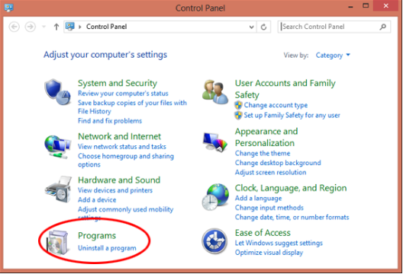

1. Click Turn Windows features on or off, and the user will see window as image below.

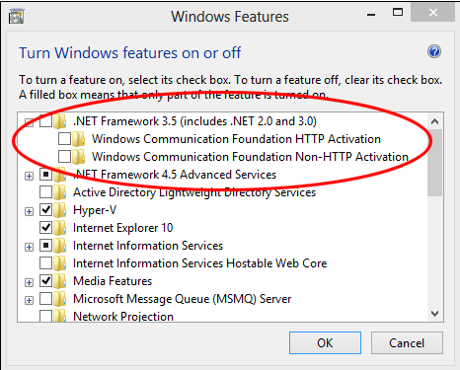

The User can enable this feature by click on .NET Framework 3.5 (include .NET 2.0 and 3.0) select it and click OK. After this step, it will download the entire package from internet and install the .NET Framework 3.5 feature.

But if the user does not have an internet connection, this steps cannot be applied.

### Sql Server 2014

1. Download the SQL Server 2014 R2 Express Edition with Advanced Services (64 bit) from the following URL: <http://download.microsoft.com/download/E/A/E/EAE6F7FC-767A-4038-A954-49B8B05D04EB/ExpressAdv%2064BIT/SQLEXPRADV_x64_ENU.exe> once the download is complete, continue with the Step-by-Step Installation section below.
2. Double click the SQLEXPRADV\_x64\_ENU.exe file. When prompted to Choose Directory for Extracted Files, click OK to use the default directory, or click Browse...and select a different directory
3. Upon starting the installation, the following window appears:

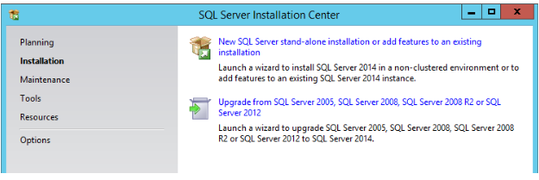

1. Click New SQL Server stand-alone installation or add features to an existing installation.
2. Select I accept the license terms checkbox to accept the license terms, and click next.

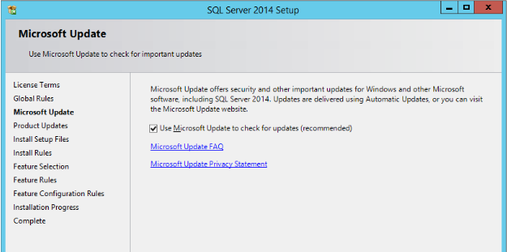

1. In the Microsoft Update window, select the checkbox in order to use Microsoft Update to check for updates after you finish the installation, and then click next. The Install Rules window may open.
2. The SQL Server installation program checks your machine to make sure it meets the hardware and software requirements for installing the SQL Server. If you get any errors in the results, use the link in the error message to receive more information.

If you receive errors in this report, do not move on to the next step until you resolve them. Once you are done, click Next to continue to the Feature Selection window.

1. Select the features to install. We are going to choose our features manually in the Feature Selection window

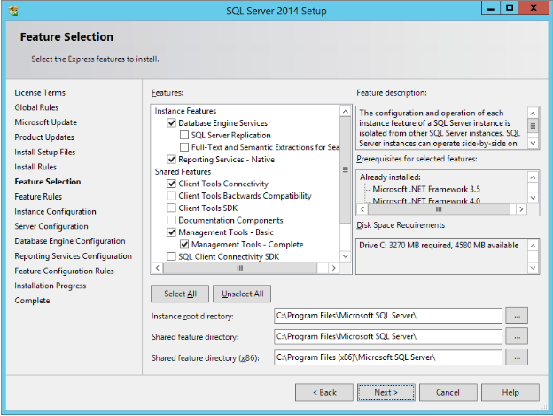

1. Choose the following features to install:

Instance Features:

* + Database Engine Services
  + Reporting Services – Native

Shared Features:

* + Client Tools Connectivity
  + Management Tools – Basic
  + Management Tools – Complete

Note: It is highly recommend not to choose all the features on a production server if you don't need them. Choose only the features listed above. You can also specify a custom directory for Instance directory and shared components by using the field at the bottom of the Feature Selection page. To change the installation path, either update the path in the field at the bottom of the window, or click Browse to move to

1. Installing SQL Server 201410 an installation directory. The default installation path is C:\Program Files\Microsoft SQL Server and C:\Program Files (x86)\Microsoft SQL Server.

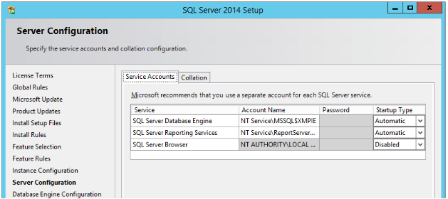

1. In the Server Configuration window, Service Accounts tab you can select the service accounts for the SQL Server actions. Each service in SQL Server represents a process or a set of processes that manage authentication of SQL Server operations with Windows. Each service can be configured to use its own service account. For SQLEXPRESS Database installation, simply leave the settings with the default configuration. Once you configure this step, click the Collation tab

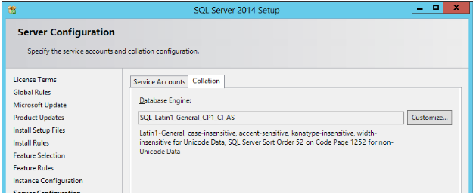

1. Define the collation as SQL\_Latin1\_General\_CP1\_CI\_AS (as shown above) and then click Next to move to the Database Engine Configuration window.

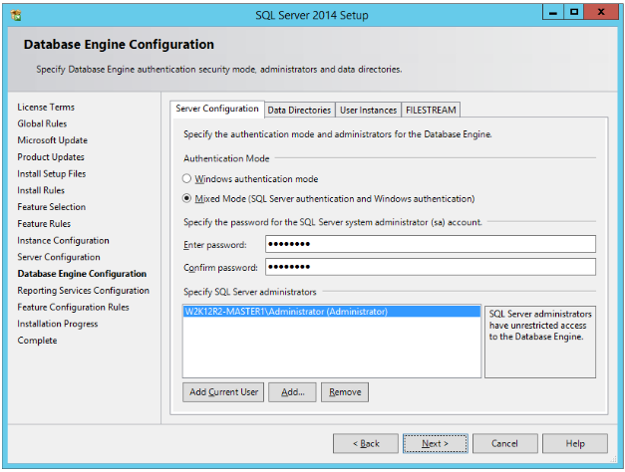

1. SQL Server can operate in one of two security (authentication) modes:

• Windows authentication mode which allows a user to connect through an operatingsystem user account or a domain user account. Attention :If you select this option, after the installation of SQL Server is done make sure to complete the section Creating a Login in SQL Server for Windows Authentication on page 24.

• Mixed mode which allows users to connect to an instance of an SQL Server using either Windows authentication or SQL Server authentication. In the Database Engine Configuration window, Server Configuration tab, selectMixed Mode, enter ‘Xmpiesa1’ in the Enter password field, confirm it in the Confirm password field, and then go on to the Data Directories tab.

Note: If the default Windows password complexity policy is enabled, this password may be considered as weak. You should provide a strong password in order to meet the Windows password complexity policy. In addition, make sure that the current user (Administrator) is shown the list of Specify SQL Server administrators. If not, click the Add Current User button to add the current user.

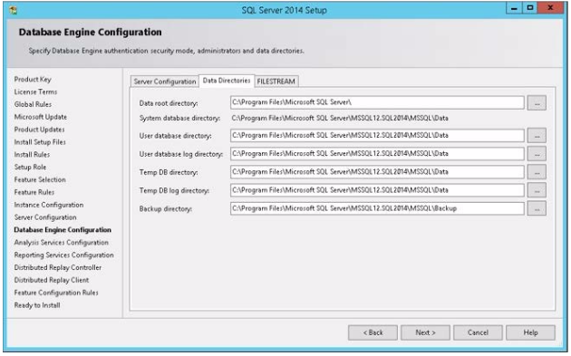

1. By default, SQL Server uses the system operation disk. Thus it is highly recommended to use the best practice according to your specific system and usage. Separating the log files from the data files can improve performance significantly.The system database tempDB is used extensively by the SQL Server. This database is rebuilt each time the server restarts. It is highly recommended to use a fast disk for this database. It is best practice to separate data, transaction logs, and tempDB for environments where you can guarantee that separation. There are important points to consider and this document does not cover them all. For small systems you can use the default configuration and later on change as needed. Click Next to continue to the Reporting Service Configuration window.

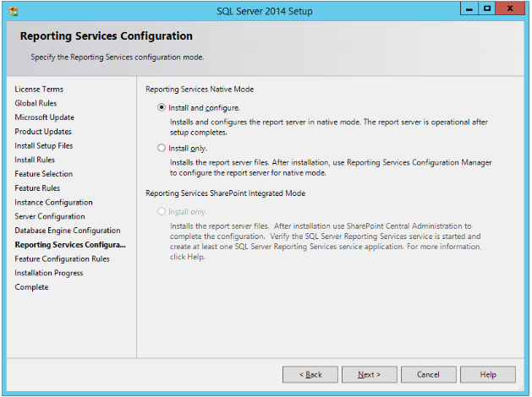

1. Choose Install and configure and then click Next The installation now starts. The Installation Progress window is displayed, listing the components being configured and indicating the installation progress

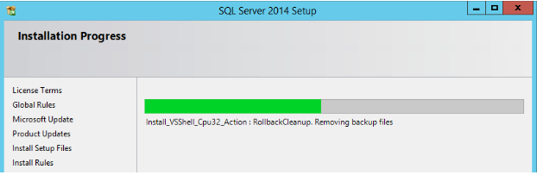

1. That is all. Considering everything went well, you should get a final report which indicates the successful completion of each installed service. You may be asked to restart your computer. Click OK and restart the computer. If no restart is required, click Close to close the Setup Wizard.

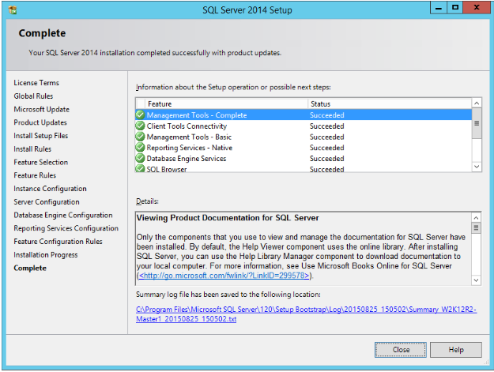

1. Close the SQL Server Installation Center.
2. Open application folder and navigate to Database, double click on BSMSscript.sql

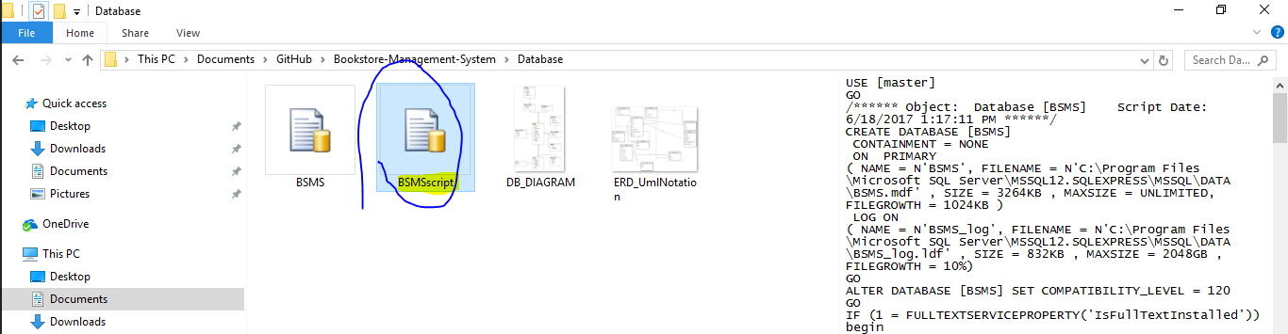

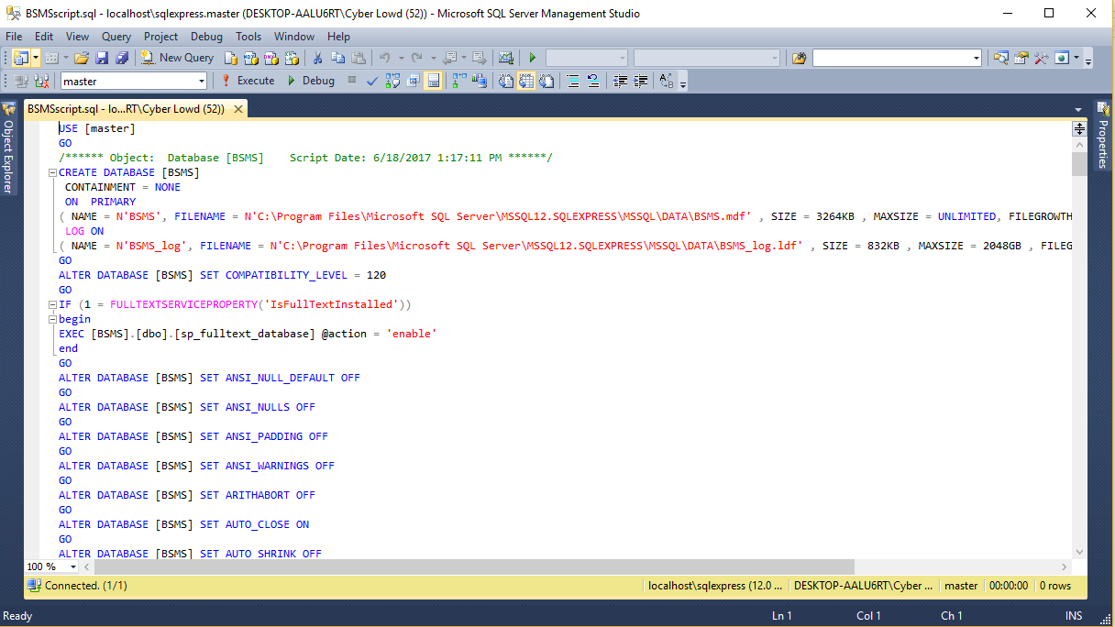

1. Once Microsoft SQL Management Studio is open as shown in the above referenced figure, click on the execute or press F5 key from the keyboard, Note : run shut cut key might varies from pc producer and version of OS

### Visual Studio 2015

1. First of all download Visual Studio Enterprise 2015. If you have DreamSpark, BizSpark or MSDN account, you can download it from there. Here, I’ve downloaded it from my MSDN account. After login in your account, you can find all software in subscriber download section and choose any version of visual studio from here.  
     
   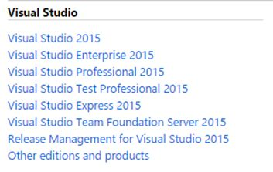  
   **Figure 1**
2. Click on any version of visual studio, and then you will see below section in a new page. Here, you can see Visual Studio Professional 2015 both 32 bit and 64 bit downloading option. You can also claim your product key by clicking on the product keys button.  
     
   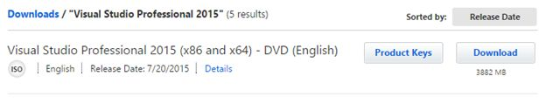  
   **Figure 2**
3. Go to the destination folder and open the folder. Inside the folder you can see these files.  
     
   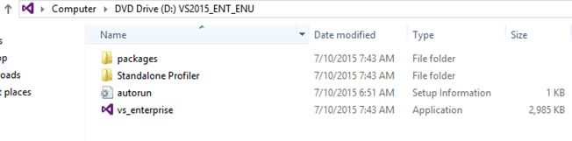 **Figure 3**
4. **Start Installation Process**  
   Open the “**vs\_enterprise**” application file and you will see the windows below one by one.  
     
   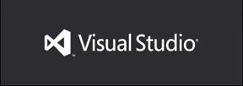  
   **Figure 4**  
     
   Then you will see two installation options and they are typical and custom. Select custom installation process and then click “**Next**” button at the bottom.
5. After that you will see figure 5. Select features that you want to install. Few feature installation may require internet connection to download setup files and install properly. So, please check internet connection before starting the installation process. Top get Universal Windows App development features, you need to select that option from the feature list. After selecting your desired features, click “**Install**” button.  
     
   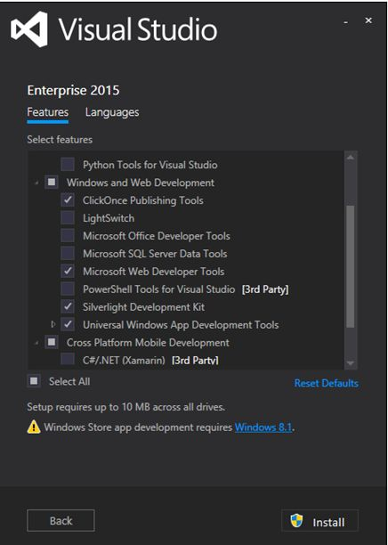  
   **Figure 5**  
     
   Then the installation process will start. It’ll take some time based on your computer configuration. High configuration PCs take average one and a half or, two hour.  
     
   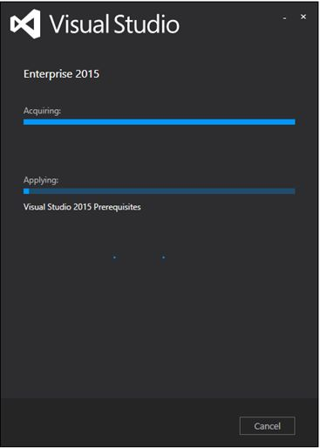  
   **Figure 6**
6. **Restarting Your Computer**  
   After completing the installation process, you will see an option to restart your computer to complete the installation process.   
     
   Hit the “**Restart Now**” button. It’ll restart your computer. After some moment your installation process will be done and you’ll get this message window.
7. **Launching Visual Studio Enterprise 2015**  
   Now launch Visual Studio Enterprise 2015 from the installed software list and they you will see below screen.  
     
   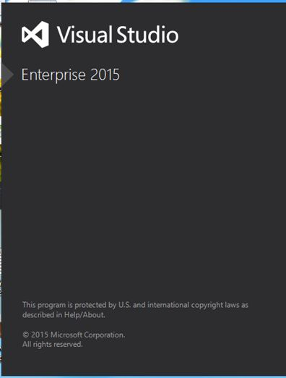  
   **Figure 7**
8. **Sign in** with your Microsoft account, you can do so or just click “**Not now, may be later**”.  
     
   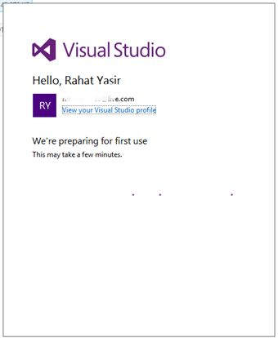  
   **Figure 8**
9. Now Your Visual Studio Enterprise 2015 is ready to use. You will see below visual studio screen.  
     
   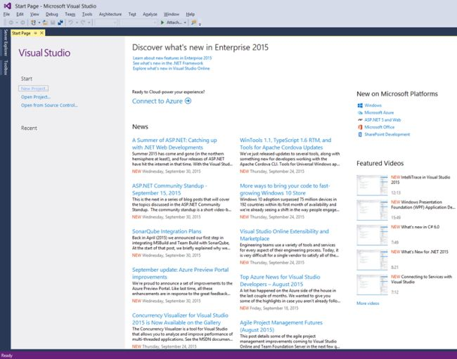  
   **Figure 9**
10. **Activating Visual Studio**  
    Now one more thing to do is to activate your Visual Studio with the product id which you’ve got from your MSDN account. Go to Help >> Register Product Key.  
      
    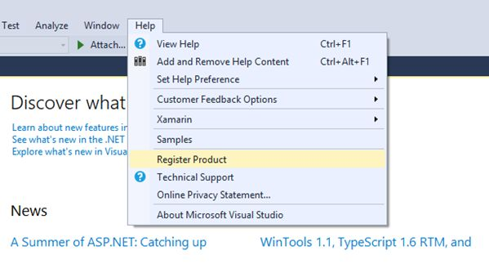  
    **Figure 10**
11. Hit the Register Product Key and you’ll see this window like below. Click the “**Licence with a Product Key**” hyperlink.  
      
    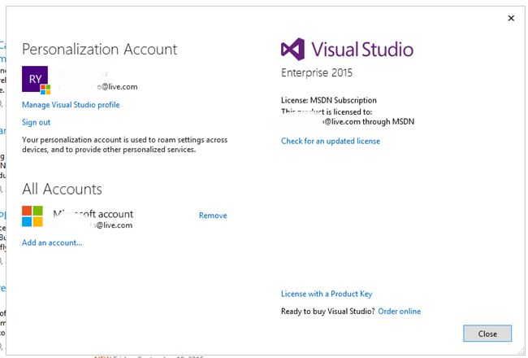  
    **Figure 11**
12. Input your product key on the below product key text box and Hit “Apply” button and you’re ready to go.  
      
    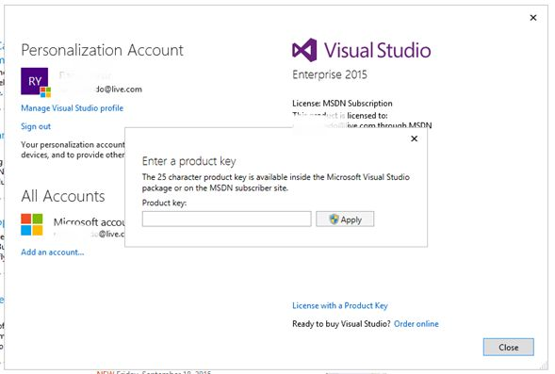  
    **Figure 12**  
      
    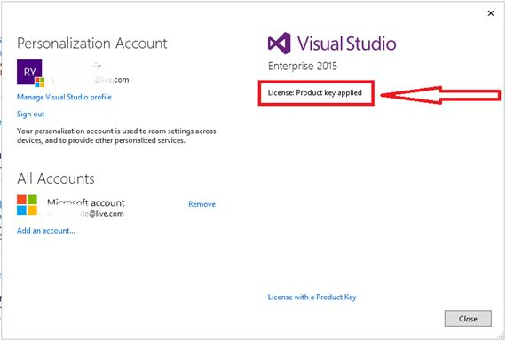  
    **Figure 13**
13. **Get Ready to Use Visual Studio**  
      
    Now you are ready to run BSMS on your local computer, alternative you could install IIS server and host application on this server without installing visual studio
14. Open BSMS Application Directory as shown in Figure 14 below

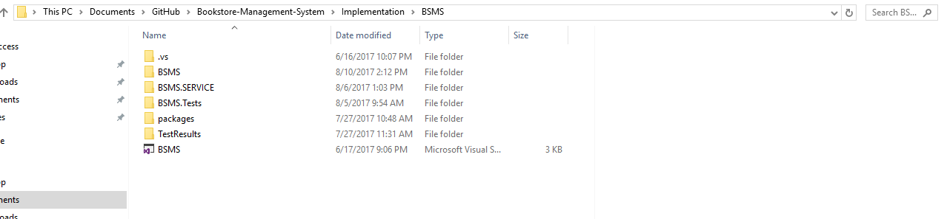

1. Double Click on BSMS to open the source code of this project then click on the start button from the top-most part of the IDE.

Note: you might be required to change database server name in web.config of bsms.service to match your own server name

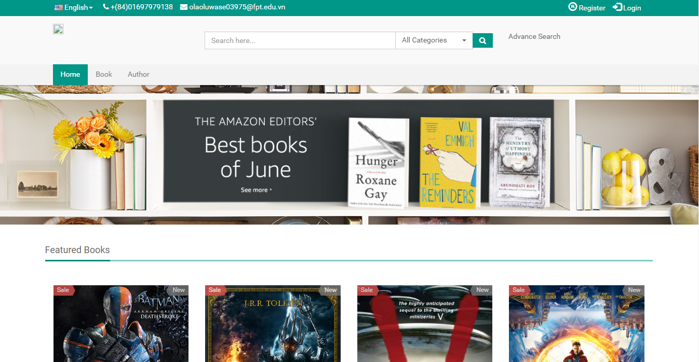

# USER's GUIDE

## Purposes

<Phần mô mục đích của user's guides>

## Functional Description

<Tóm tắt các chức năng>

## Detailed Guidelines

### Login

User click on the login icon from any page, be it the home page or booklist page

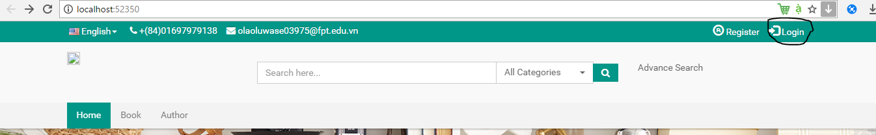

After clicking on the highlighted ui element, the login page will appear

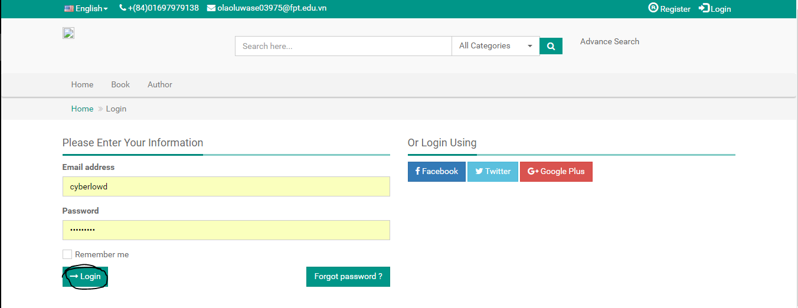

After this user will be redirected into another page

### Register

Click on the register icon from any page

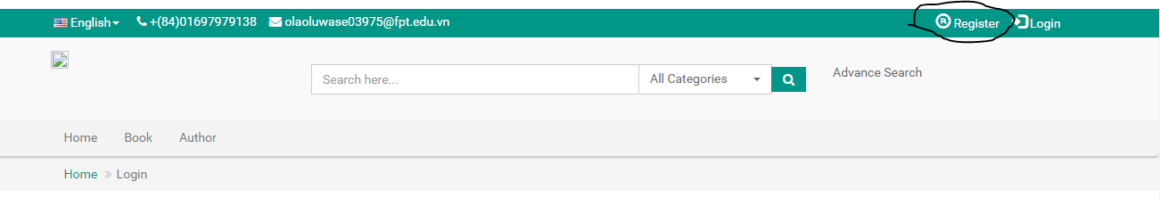

After clicking on this icon, registration page will be displayed to register new account as a customer

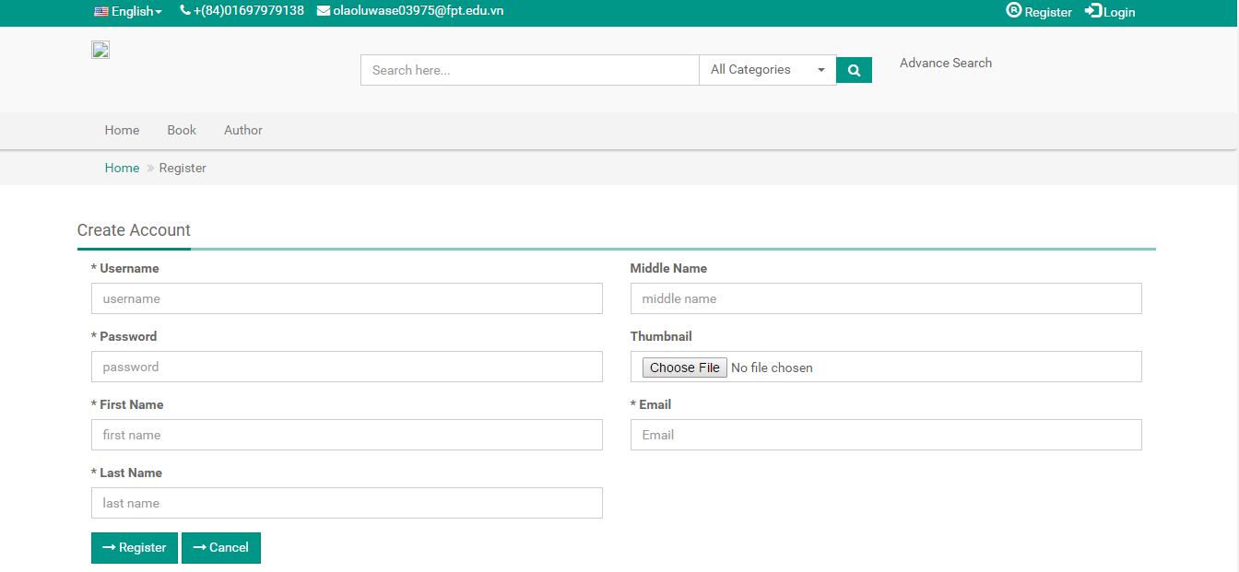

Fill in all \* field correctly then click on register button, then BSMS will automatically redirect you login page on successful registration.

### View Books

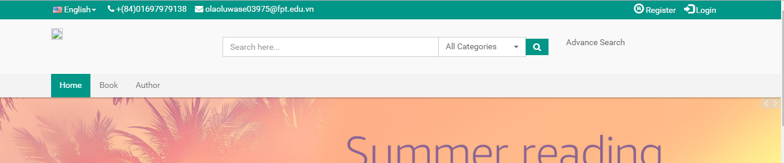

Click on the Book navigation item from any page, bsms will then redirect you to the book list page.

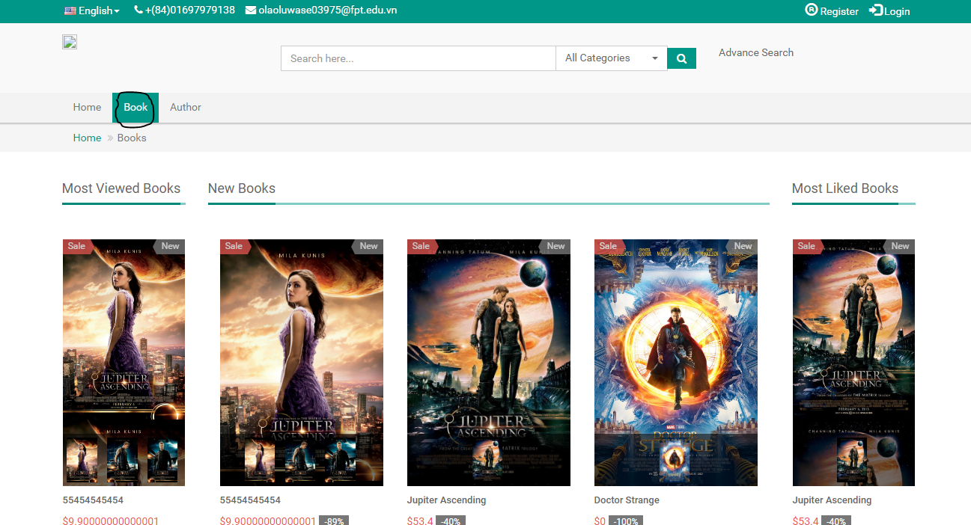

Click on any book from the list in the book list page.

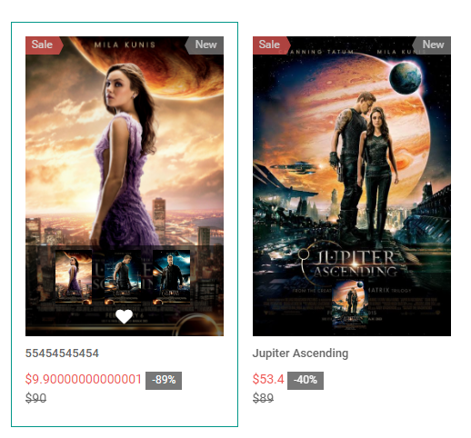

Then the book detail page should be shown as the figure below

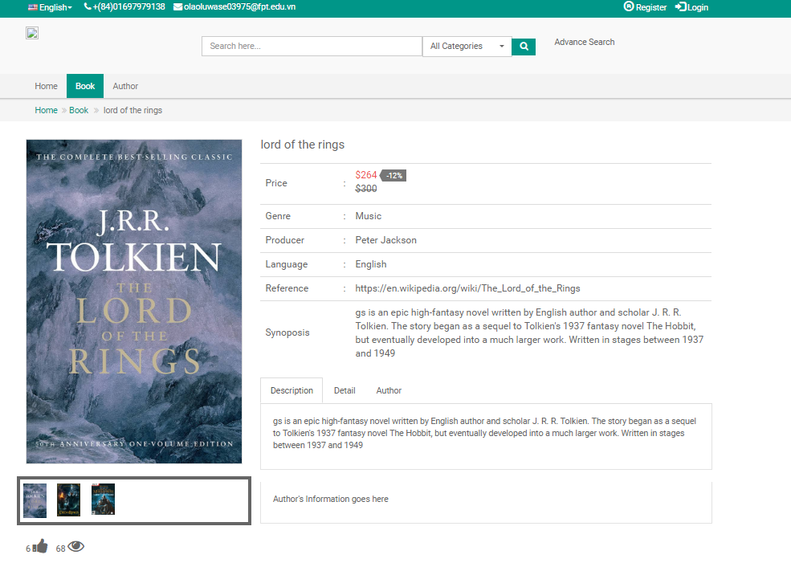

### Read Online

To use this feature, you need to login as a customer, and also you need to find a book has a pdf version

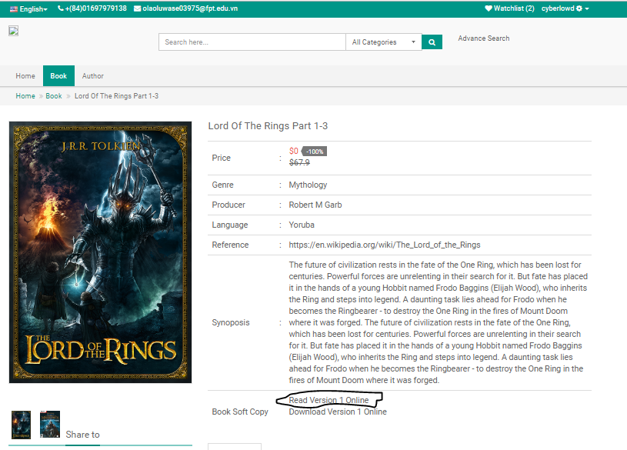

If you find any book with pdf. You will see this option book soft copy in the book detail information, click on the “Read Version nth Online” where n is the number of softcopy (version 1,2…. nth)

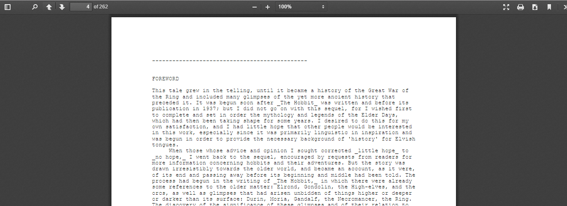

### Download Book

To use this feature, you need to login as a customer, and also you need to find a book has a pdf version

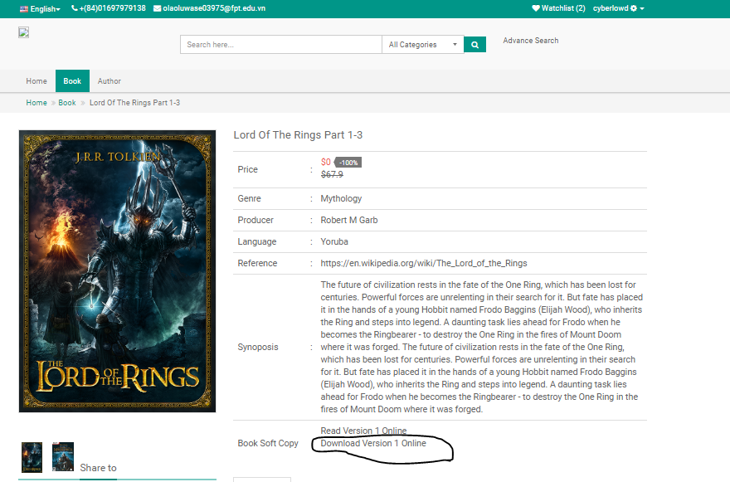

If you find any book with pdf. You will see this option book soft copy in the book detail information, click on the “Download Version nth Online” where n is the number of softcopy (version 1,2…. nth)



### Like Book

From the book list page as described in 2.3.3 hover on any book from the list, if you are logged in as user you will see the like button on hovered item like the figure below.

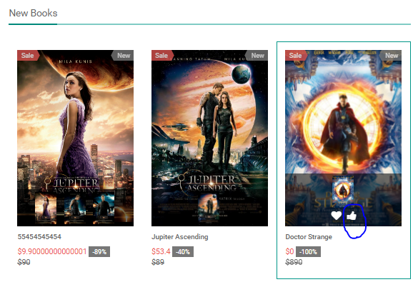

Now click on the like icon, and now you should receive a success message, and the like icon will change to dislike.

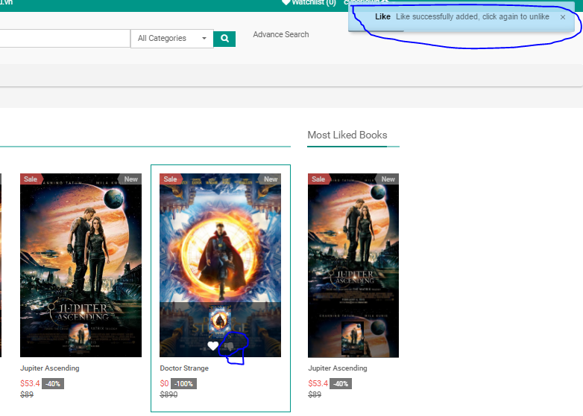

### Dislike Book

Once a valid customer clicked on the like icon from the book page, they will then be to see the dislike icon as show in the figure above.

To dislike/unlike a previously liked book then customer user will be required to click on the dislike icon that appears on hover of any if such book has been liked.

### Rate Book

Once you click on a book, you will be able to see rating of the book as long as you are logged in, click on the star as shown in the figure below.

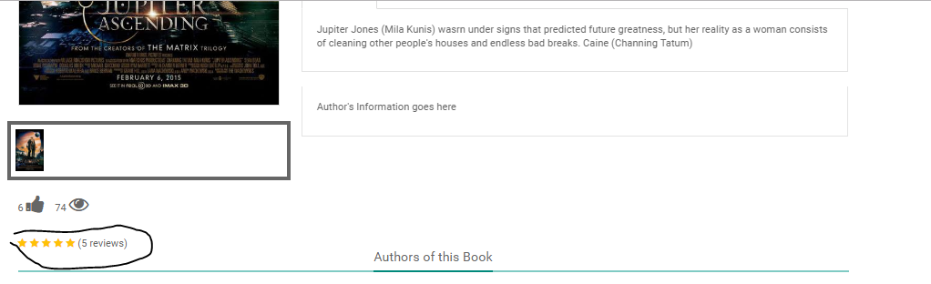

### Like Book

### Add Book To Wish list

Once you hover on any book from the book list page you will see the love icon which signifiers wish list alongside with the like or dislike button.

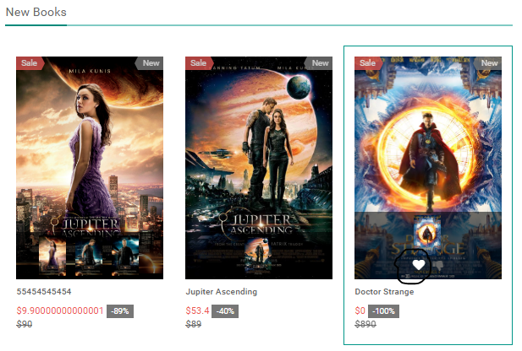

Click on the circled icon, then you will receive a notification on right top most part of your browser saying wishlist operation completed, and wishlist count should increase if such book didn’t previously exist.

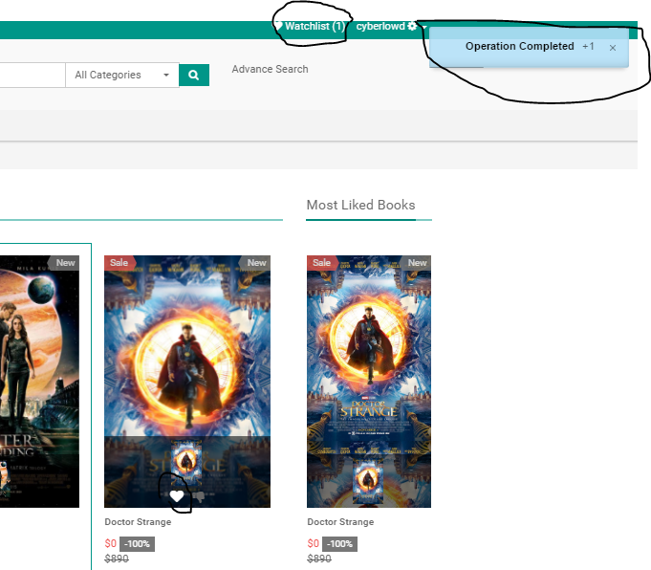

### View Wish list

From the topmost level navigation bar click on the wishlist nav item. See the figure below for more insight.

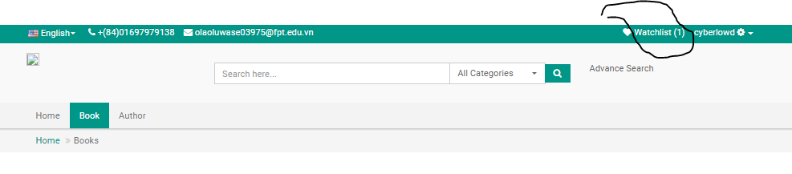

After clicking on this navigation item, then the wishlist page should display as follow with the list of all books added.

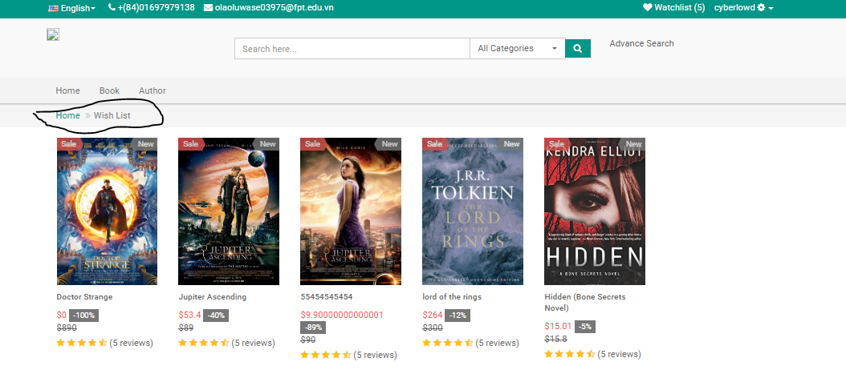

### Remove from Wishlist

Hover on any of the book from the wish list page, then a “X” icon should display

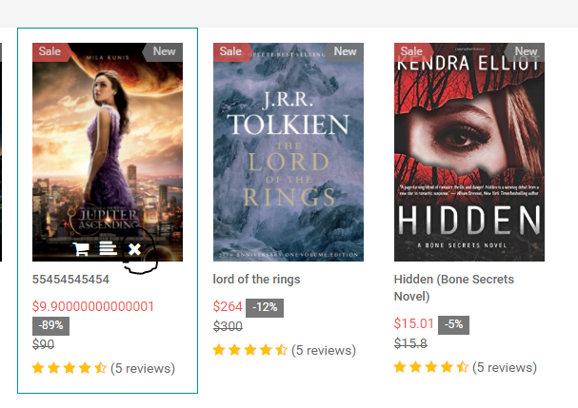

Click on the marked icon, then a popup box should be displayed on the page

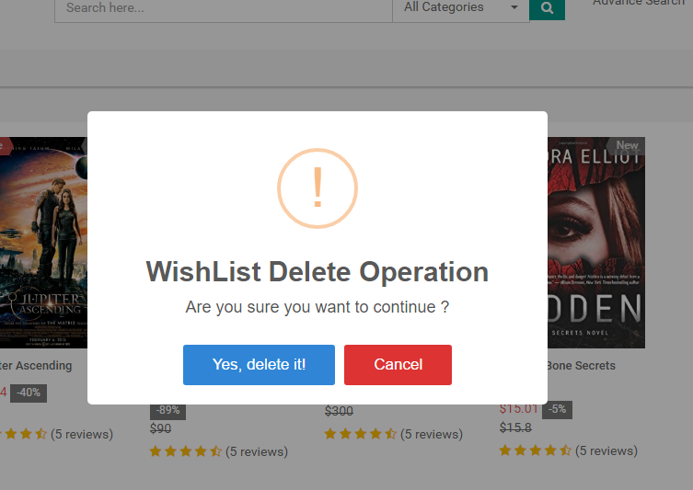

Click on “Yes Delete it”, then the book should automatically disappear from your wishlist page, together with notification message on the top-most right hand side of your browser.

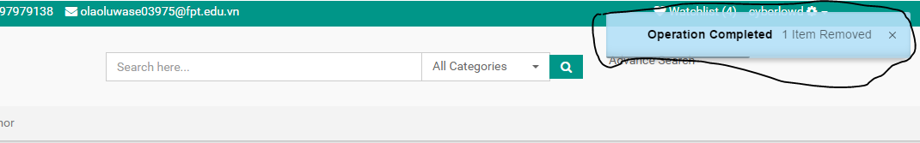

### Change Password

From the top most part of BSMS web application, once logged in you will be able to see the setting icon alongside with your username, click on this, the page should then display as below

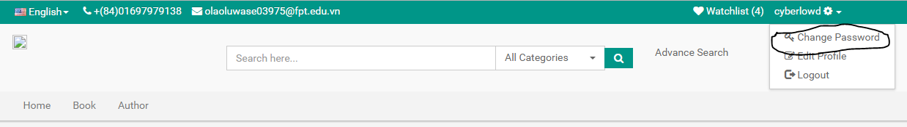

Click on the Change password, with the key icon. This should take you to the change password page as shown in the figure below.

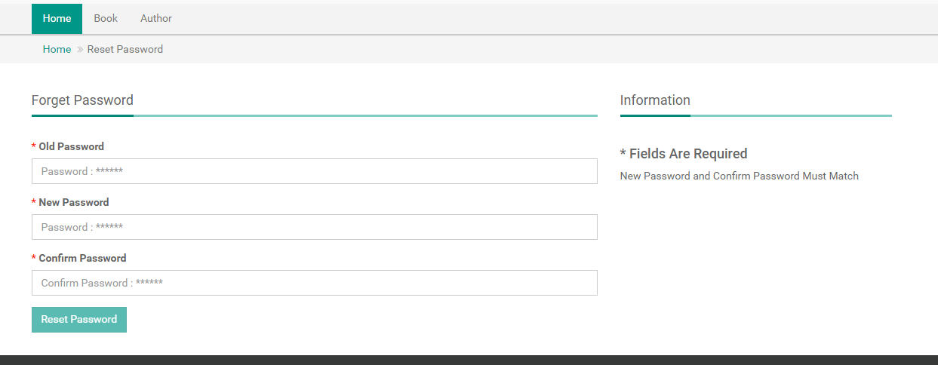

Fill in all data correctly, and follow the rules show in the left hand side, once this is done you will be automatically logged out to test your new password

### Edit Profile

From the top most part of BSMS web application, once logged in you will be able to see the setting icon alongside with your username, click on this, the page should then display as below

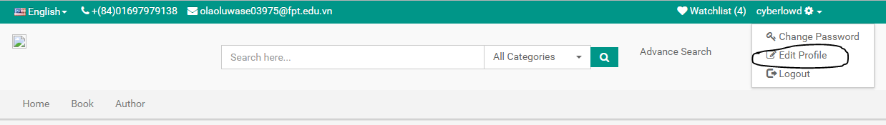

Click on the edit profile, with the edit icon. This should take you to the change password page as shown in the figure below.

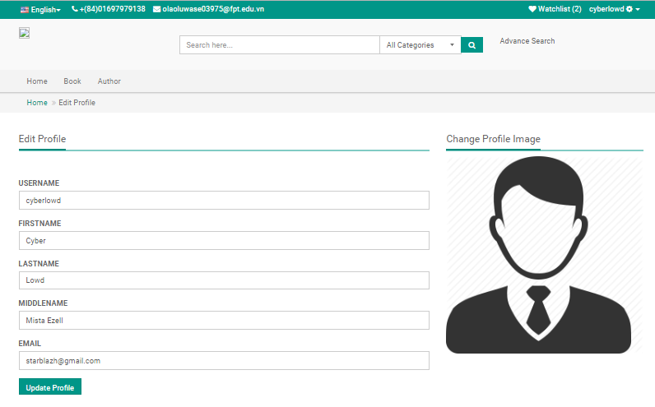

Change information you desire to change and click on the Update Profile button. To change profile picture, click on the image, and pick any image from your local file storage.

### Logout

From the top most part of BSMS web application, once logged in you will be able to see the setting icon alongside with your username, click on this, the page should then display as below

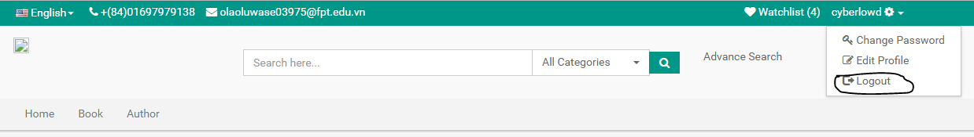

### Forget Password

From the login page click on the Forget Password icon

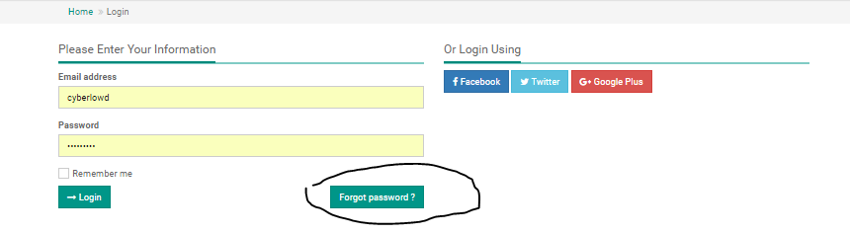

Forget password page should be shown, with a text field to input your registration email address.

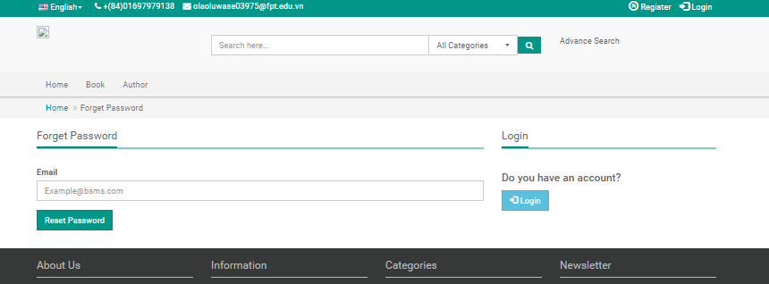

Fill in this field and click on reset password, if your email address on BSMS then you should a message as below.

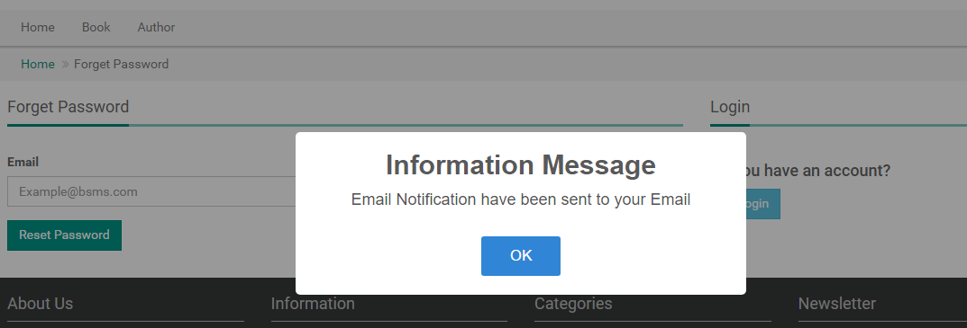

If your email is a valid one, then you should see reset email in your inbox.



Open the Email and click on the link in the email.

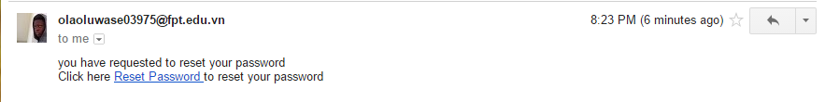

After click on the Reset Password like, you should be redirected to the reset password page.

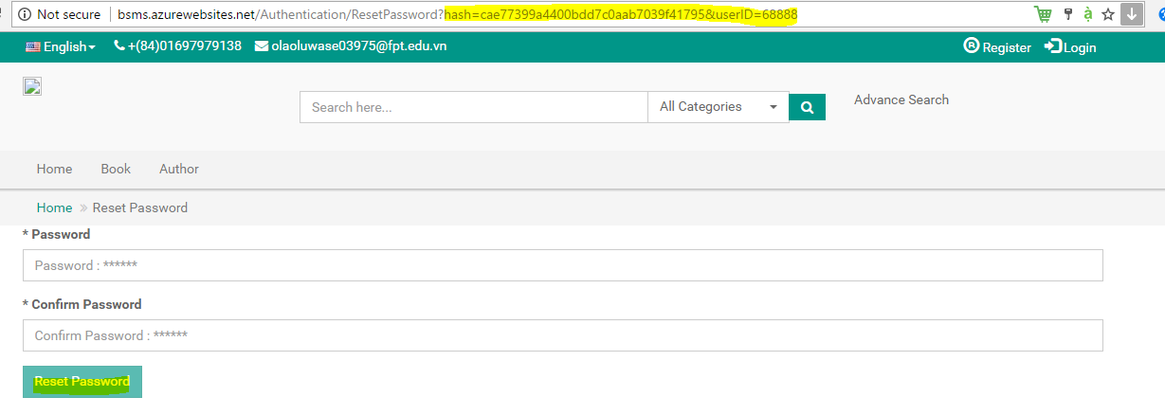

Fill in the field correctly following the BSMS rules, then click on the reset password, this should lead you to the login page after receiving success message.

### Search

From the top level of bsms application, there is a search box which should appear from any page, type anything inside, as long as there are match for this keyword, you will receive a suggestion

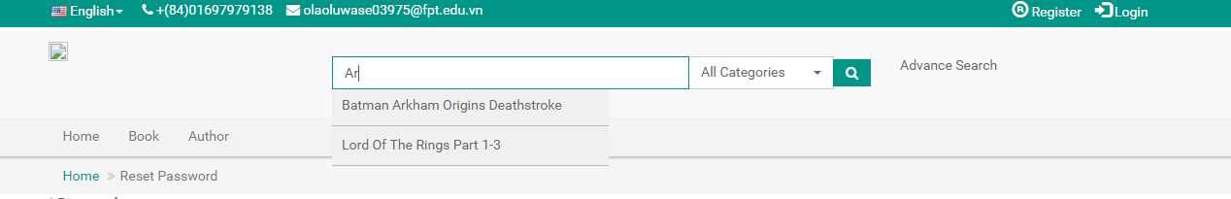

I f any of the suggestion matches the book you are looking for then click on it, this should lead you directly to the book detail page of such book.

### Add Category

Login as administrator, from the login page you should be redirected to the Admin Dashboard, on the sidebar of the dashboard click on the Category.

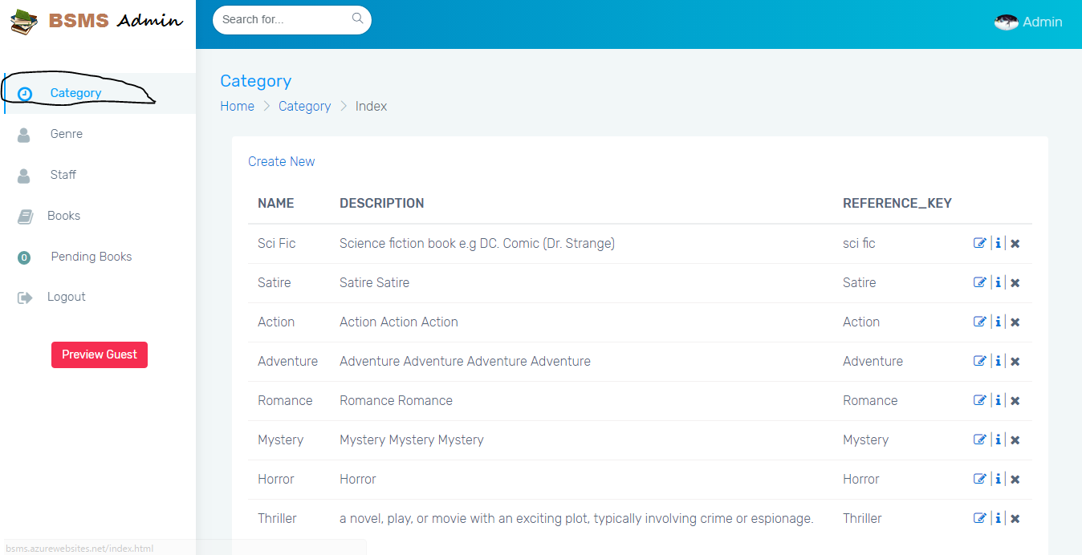

Once you click on the Category then BSMS should display the result as the above figure depicts. Click on the Create New Button from the category page.

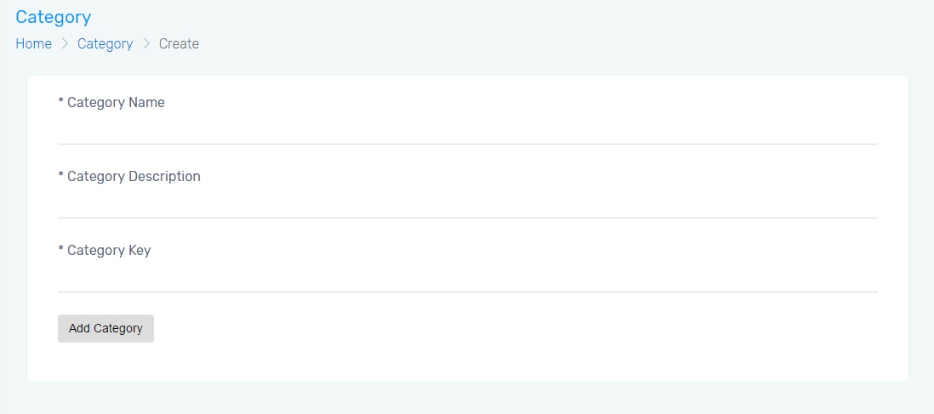

Fill in the fields marked “\*” as they are required fields, then click on the “Add Category” button

### Update Category

Login as administrator, from the login page you should be redirected to the Admin Dashboard, on the sidebar of the dashboard click on the Category

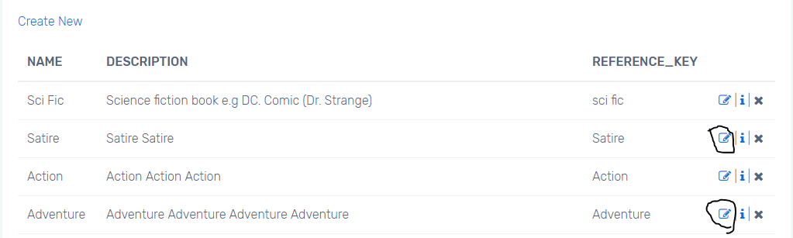

Click on any of the item with edit icon, which will redirect to you to the edit page

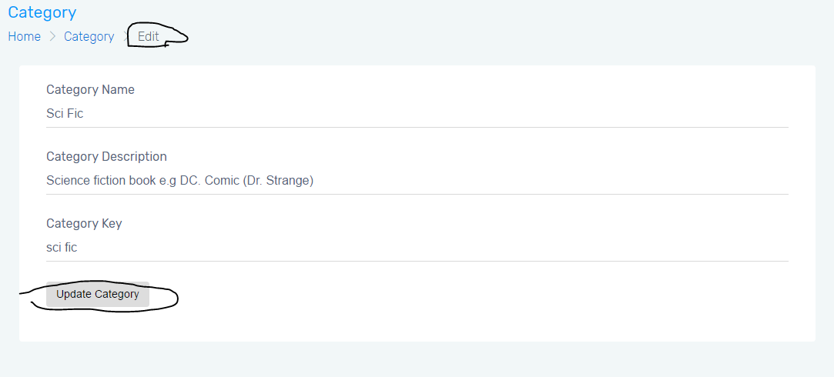

Update category information and click on the Update Category button.

### Delete Category

Click on the “X” icon from any item in the category dashboard

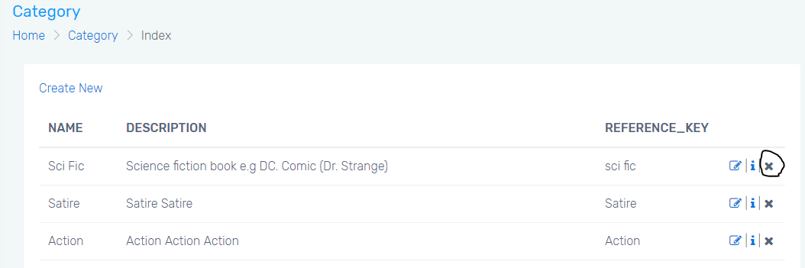

You should receive a confirmation, saying “Are you sure you want to delete this? ”

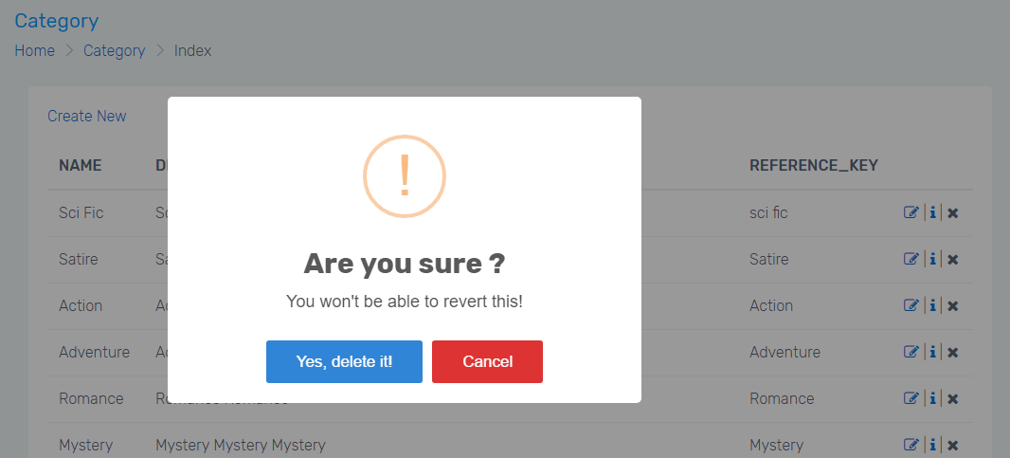

Click on “Yes Delete it” to delete, and once you click on this button, item should immediately disappear from the list completely.

### View Genre

Login as administrator, from the login page you should be redirected to the Admin Dashboard, on the sidebar of the dashboard click on the Genre.

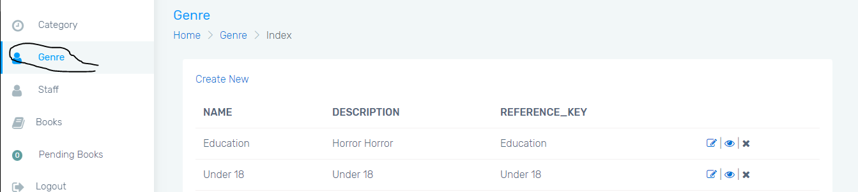

### Add Genre

From the View Genre page, click on the “create new” Hyperlink.

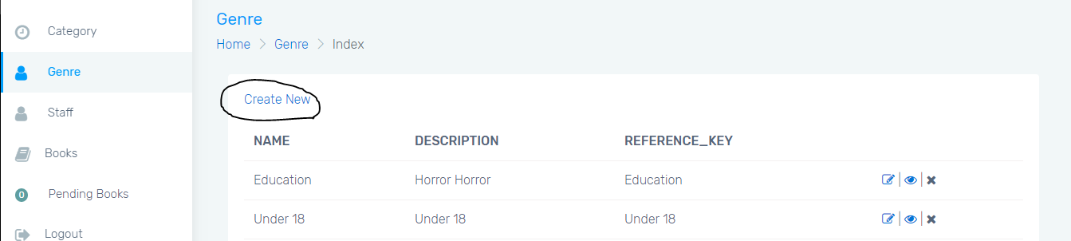

This should lead you to Add Genre page as shown below

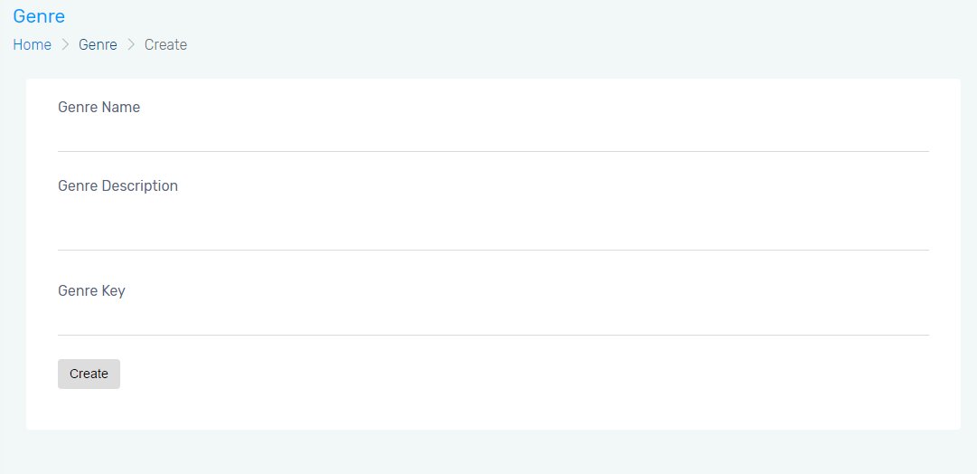

Fill in the all fields, then click on the “Create” button

### Update Genre

Login as administrator, from the login page you should be redirected to the Admin Dashboard, on the sidebar of the dashboard click on the Genre



Click on any of the item with edit icon, which will redirect to you to the edit page

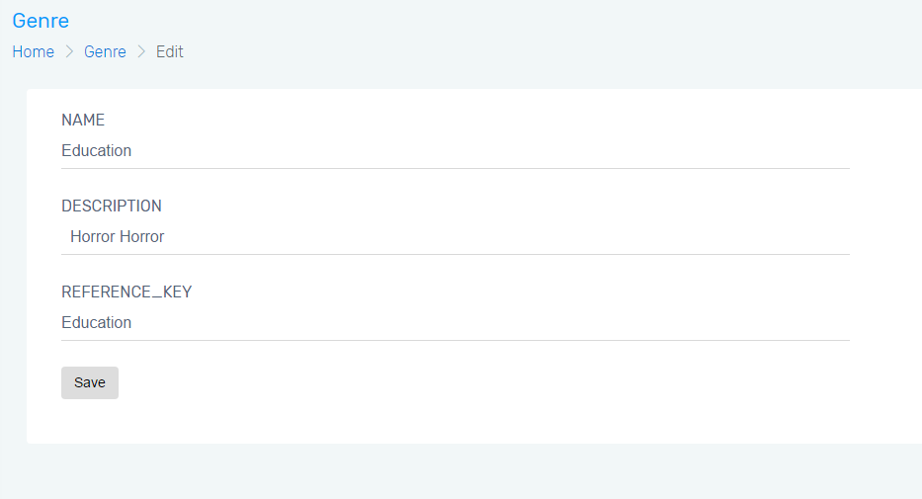

Update genre information and click on the Save button.

### Delete Category

Click on the “X” icon from any item in the category dashboard

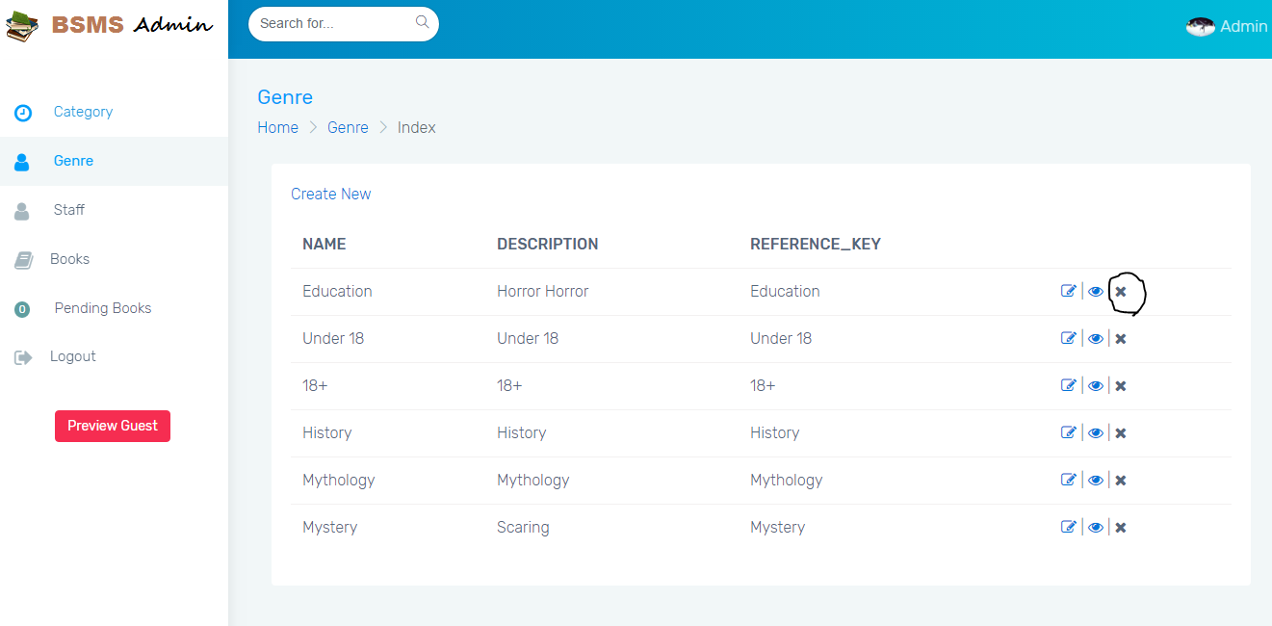

You should receive a confirmation, saying “Are you sure you want to delete this? ”



Click on “Yes Delete it” to delete, and once you click on this button, item should immediately disappear from the list completely.

# PROJECT RESULT REPORT

## Product Judging

## Project Summary

## Lessons Learnt

...